Exploring weather trends : Project I

Hi am from Chennai and I chose Bangalore as my closest city from city_list table.

The data was extracted from the given workspace with the query as shown below:
select city_data.year as year,city_data.avg_temp as citytemp,global_data.avg_temp as globaltemp from city_data,global_data where city_data.year=global_data.year and city_data.city='Bangalore' and global_data.avg_temp!=0 and city_data.avg_temp!=0;

The query ran successfully and the output data was downloaded as a csv file.

The moving averages was calculated with a period of 9 years to get a desired smooth graphical representation.
The screenshot has been attached below:

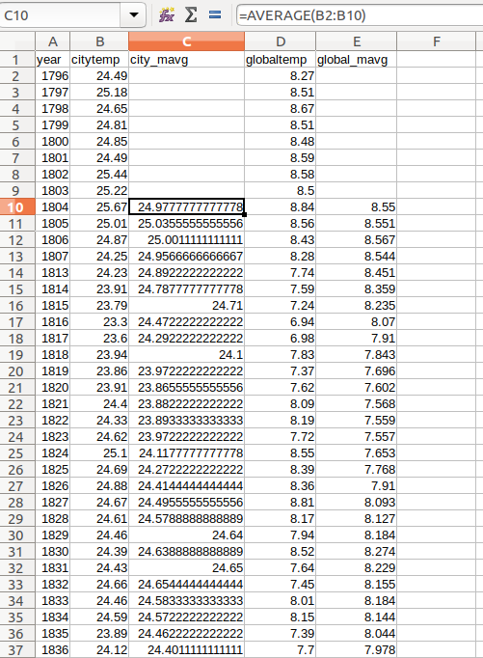

The graphical representation of the data comparing average temperature of my city with the global temperature was obtained as shown below :

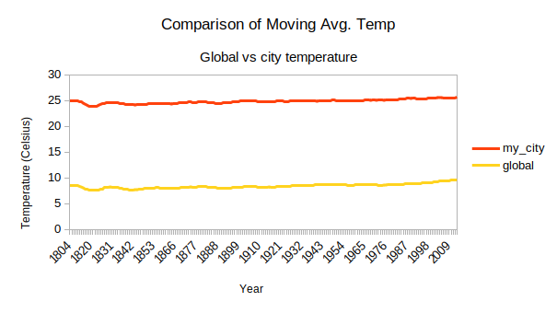
Fig : Avg. Temp comparison – My city vs Global

Observations made from the graph :

- My city temperature seems to be ranging from 24-25 degrees on an average.

- The global temperature seems to be ranging from 7-9 degrees on an average.

- Over the past 20 years, there seems to be a noticable increase in avg. Temperature for both city as well as global.

- My city is approximately three times hotter than the avg. Global temperature.

